Preparing the Demo Environment for the Role Mining & Maintenance Scenarios

Introduction

This demonstration is pre-configured on the IdentityIQ 6.1 Partner VM.

Configuration

Before you can start with the demo, please verify that the “Business and IT Role Mining” task contains the following applications:



The Role Mining & Maintenance Demonstration

Demo startup

1. Open up different Firefox browser sessions and log in as the following players:
   1. Jerry Bennett (Go to Analyze / Advanced Analytics)
   2. Amanda Ross (leave the session at her Dashboard)
2. Open up “Active Directory Users and Computers” and select the “Groups” container
3. Put the following names in your copy buffer so you can easily paste the contents later on (found in the Role Mining Demo.txt file on the desktop):  
     
   Bobby Stephens; Mike Chapman; Dawn Oliver; Leonard Williamson; Louise Payne; Nathan Banks; Edna McCoy

The Role Mining & Maintenance Demo Scenarios

Scenario 1: Initial Role mining

1. In the Jerry Bennett browser, go to Analyze / Advanced Analytics
   1. On the “Identity Search” tab, enter “Tax Accountants” into the “Job Title” selection box and select a few “fields to display”
   2. Click on “Run Search”
   3. You will now see all Tax Accountants. In the “Result Options” box, select “Show Entitlements”

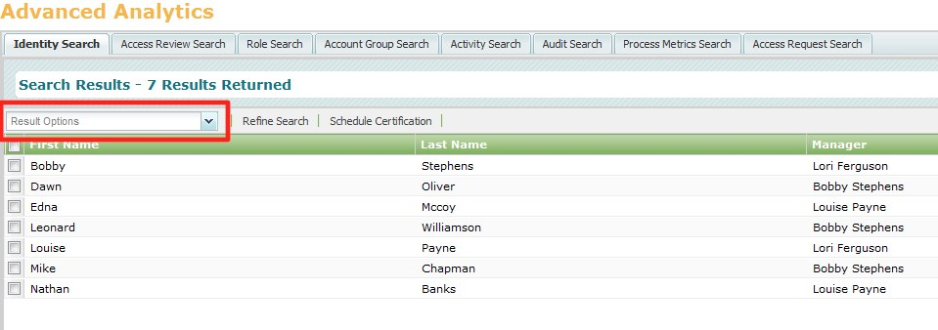

* 1. You will now see the entitlements and the overlap or quality. You can click on the Compensation group to show the matching and non-matching members.  
       
     Explain how this entitlement analysis is the exact same procedure used to create or update the IT roles for every Business role mined later on.
  2. Close the entitlements screen
  3. Click on “Leonard Williamson” and show the Entitlements tab, then focus on the Additional Entitlements / Active_Directory  
       
     Tell how we will now “Roll up” these entitlements into roles, using role mining.   
     As Role mining uses current data “Who has access to what” that current data should be clean and appropriate!

1. Go to Define / Roles and click on the Role Mining tab
   1. Right-click on the “Business and IT role mining” task and select “Execute”
   2. Go to the “Role Mining Result” tab and click refresh to verify if the task has finished.  
        
      Explain how the role mining task will now use the exact same “Entitlement Analysis” to create IT roles for all mined business roles.
2. Go back to Advanced Analytics and search for the Tax Accountants again.
   1. Click on “Leonard Williamson” again and show the Entitlements tab
   2. See how the “Additional Entitlement” for AD is now gone.
   3. Click on the “IT Role for MiningDemo.Accounting.Tax Accountant” role and show the Entitlement is now a part of this role.

Scenario 2: Update your previous Role mining results

**Optional:** If you just want to show how IdentityIQ can update mined roles, you can prepare scenario 1 upfront and only deliver scenario 2 in front of the customer.

**Note:** Skip to step 2 if you just performed scenario 1 in front of the customer

**Note:** You can prepare all the actions in Step 2 if this is your “first” scenario. In that case, just show the additional entitlements and how they roll up into the existing roles.

1. In the Jerry Bennett browser, go to Analyze / Advanced Analytics
   1. On the “Identity Search” tab, enter “Tax Accountants” into the “Job Title” selection box and select a few “fields to display”
   2. Click on “Run Search”
   3. **Note: Skip this step if you have performed Scenario 1 in front of the audience.**You will now see all Tax Accountants. In the “Result Options” box, select “Show Entitlements”  
        
      You will now see the entitlements and the commonality or quality.   
        
      Explain: how this entitlement analysis is the exact same procedure used to create or update the IT roles for every Business role mined.  
        
      Close the entitlements screen
2. Add all the Tax accountants to the “Tax Authority” group in AD
   1. Go to “Active Directory Users and Computers” and add the following list of users to the “Tax Authority” group.  
        
      Bobby Stephens; Mike Chapman; Dawn Oliver; Leonard Williamson; Louise Payne; Nathan Banks; Edna McCoy
   2. Re- aggregate AD and refresh the Identity cubes for the changes to be registered on the cube. Hit the keys CTRL-ALT-1 to start the refresh
3. Go back to Advanced Analytics, re-run the “Tax Accountants” search and check the cube for “Leonard Williamson” Note that “Tax Authority” shows up as an Additional Entitlement on AD.  
     
   As this is true for all Tax Accountants, we need to “Update” our role model to reflect these changes.
4. Click on the “IT Role for DemoRole.Accounting.Tax Accountant” role and show the Entitlements that are part of this role. Note that the “Tax Auhority” group is not a part of the role.
5. Go to Define / Roles and click on the Role Mining tab
   1. Right-click on the “Business and IT role mining” task and select “Execute”
   2. Go to the “Role Mining Result” tab and click refresh to verify if the task has finished.  
        
      Explain how the role mining task will now update the roles using again, all current access and as a result, add this specific entitlement to an existing role.
6. Go back to Advanced Analytics and search for the Tax Accountants again.
   1. Click on “Leonard Williamson” again and show the Entitlements tab
   2. See how the “Additional Entitlement” for AD is now gone.
   3. Click on the “IT Role for MiningDemo.Accounting.Tax Accountant” role and show the “TaxAuthority” Entitlement is now a part of this role.

History

|  |  |  |
| --- | --- | --- |
| Date | Changes | Comments |
| August 13th 2012 | Initial version |  |
| October 30, 2013 | Updated to SERI 6.1 standard |  |
|  |  |  |
|  |  |  |